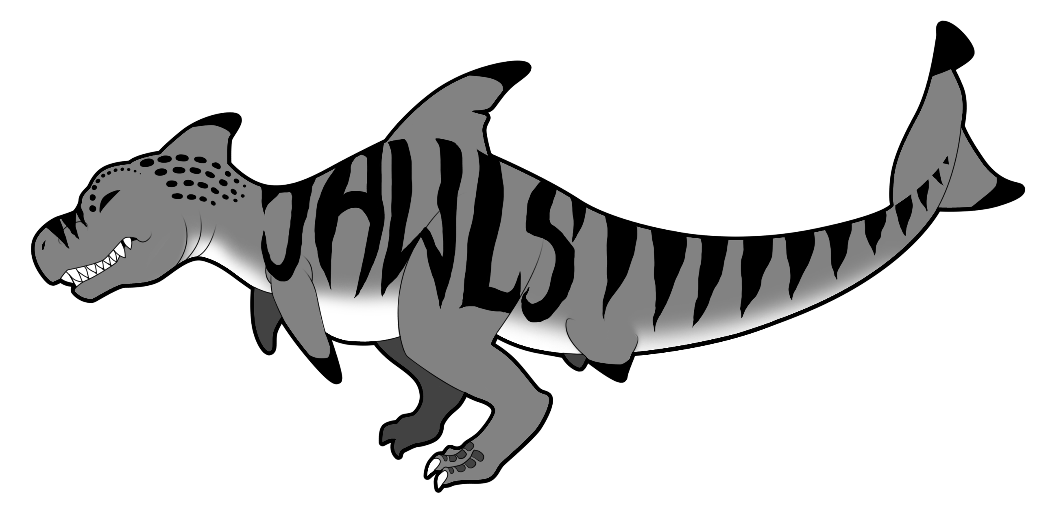
Team Jawlz

Blobby

Fall 2011

Jonathan Frick – Programmer – Physics

Daniel Regan – Producer – AI, Particles, Object Factory, Serializer

Garrett Schafer – Technical Director – Core Engine, Sound, Tools, Animation

Jarrod Sherwin – Lead Designer, Assistant Producer – Graphics, Text, Game Logic

Table of Contents
Cover Page 1
Table of Contents 2
Introduction 4
Game Flow 4
Game Mechanics 5
Game Characters 6
Game Resources 7
Game Environment 8
Game Controls 9
Visual Design 9
Audio Design 10
Behavior Design 10
Physics Design 10
Multiplayer Design 11
Appendix A: Art List 11
Sprites 11
Fonts 13
Source 13
Appendix B: Audio List 14
Sounds 14
Music 14
Source 15

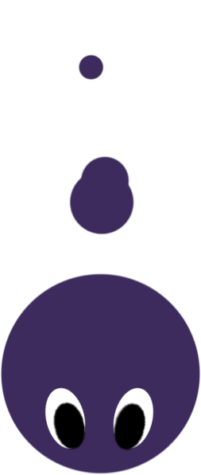
Introduction
Blobby is a game about moving fast. It is a 2D vertically scrolling racing platformer in which the player controls Blobby, who must beat a falling guillotine to the bottom of each level. In order to do this, Blobby can use his boost ability to rocket ahead of the guillotine for a short time. If Blobby goes fast enough, he can even break platforms that would otherwise be obstacles. He can also pick up Power Gems, which make him larger, recharge his boost, and increase his density so Blobby retains more of his speed after breaking a platform, and even give points to the player! Blobby can also find Multiplier Gems, which multiply any points the player earns and temporarily increases how much the boost is recharged by picking up Power Gems. Blobby can even find Life Gems that give him an extra life!

Game Flow
When gameplay begins, the player gains control of Blobby, and may move him left and right, as well use his boost. Also, the guillotine will begin falling once a countdown finishes. This will immediately engage the player as they are thrust into a situation where they need to move, and move fast, or perish. Players will progress through the game by falling down the level. Players can boost for a short time to gain speed, and can sail through blue portals that also boost Blobby's speed. The player will want to progress because we have both a carrot and a stick – There is a goal to reach the end of the level, and the player wants to avoid death by guillotine, which is chasing Blobby and constantly forcing the player to progress. The nature of this experience is one of action. Specifically, of going as fast as possible. Verbs that could describe Blobby are move, go, run, race. A single session of the game (1-3 levels) should take between 10 to 15 minutes depending on player skill.

Game Mechanics
Movement: The player can move Blobby left and right by pressing the movement keys. When the player does, Blobby's horizontal velocity will be changed instantly. This will reward players with quick reflexes, as they can avoid obstacles with ease. It also helps to make Blobby feel maneuverable and quick.

Boosting: The player can also use a boost to increase Blobby's speed. The boost only lasts for a short time, but recharges slowly when it isn't being used. The boost can also be recharged by collecting Power Gems. Collecting a Multiplier Gem also increases how much boost is recharged by picking up Power Gems. The amount of boost remaining is represented by a vertical bar on the HUD. Blobby's speed can also be boosted by passing through a blue portal, which will give a one-time boost to speed.

Collecting Gems: In order to collect Power, Multiplier, or Life Gems, Blobby merely has to come in contact with them. Each Gem has a different effect.

Score: Every time a Power Gem is collected, the player earns 15 points multiplied by whatever value the multiplier statistic is at.

Losing: If Blobby comes into contact with the Guillotine, it sends Blobby back to the last checkpoint. If Blobby loses all of his lives, the game is over and players will be given a choice to continue from the start of the current level or to quit to the menu.

Winning: When Blobby reaches the end of the level, the player is taken to a win screen that displays the player's score, the time it took to complete the level, number of Gems, etc. before moving to the next level.

Breaking Platforms: If Blobby moves fast enough, he can break through a platform. The needed speed is determined by finding the width to heigh ratio of the platform (easier to break the larger the ratio is) and calculating the surface area. As a result, horizontally longer platforms are easier to break than taller platforms. Breaking a platform will reduce Blobby's speed based on a density variable that increases when Blobby picks up Gems and decreases when he breaks platforms.

Slow Portals: Passing through a slow (orange) portal will slow Blobby's speed down in a reverse boost, the opposite of a blue portal.

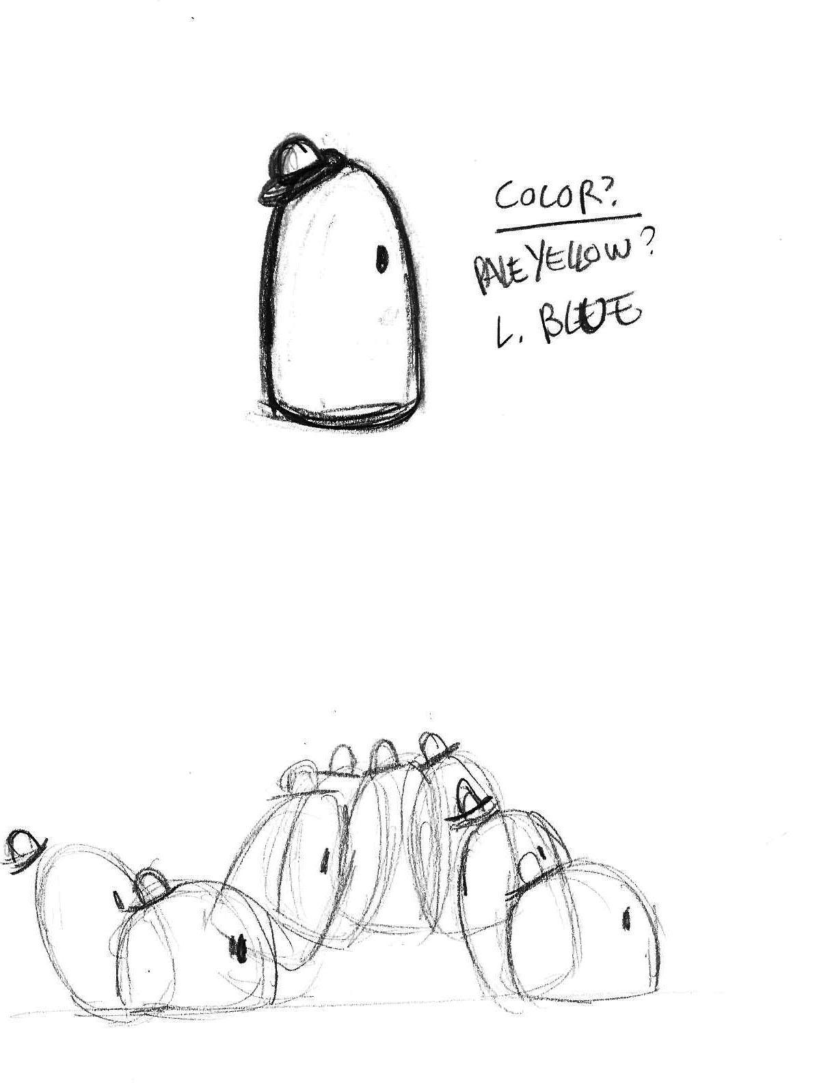
Game Characters
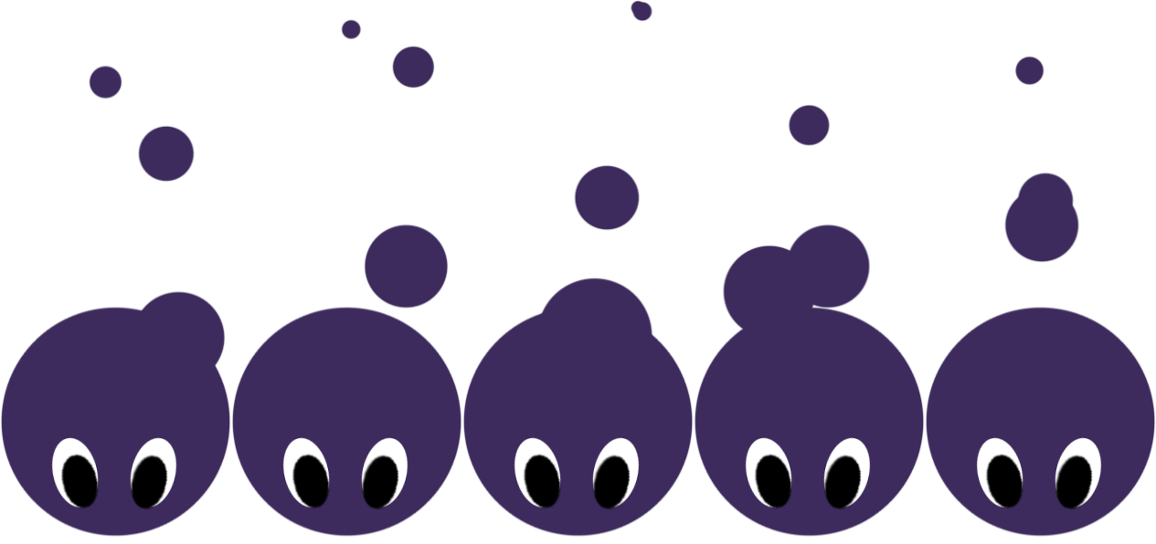
Blobby: The main character, Blobby is the protagonist and is controlled by the player. He can boost to increase his speed.

Guillotine: The antagonist of Blobby, the Guillotine chases Blobby through the level. The Guillotine's purpose is to keep the player moving fast by offering an incentive not to go slowly.
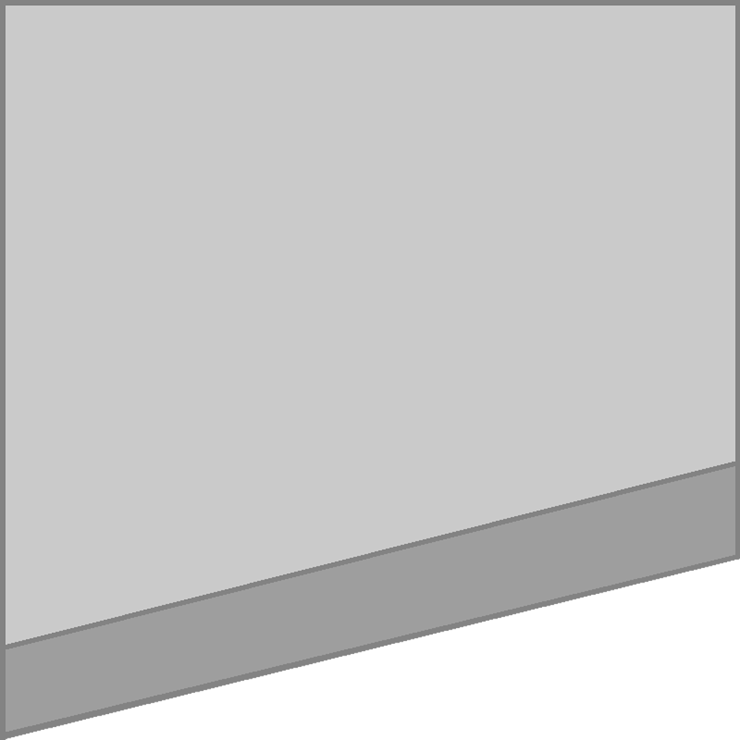


Game Resources
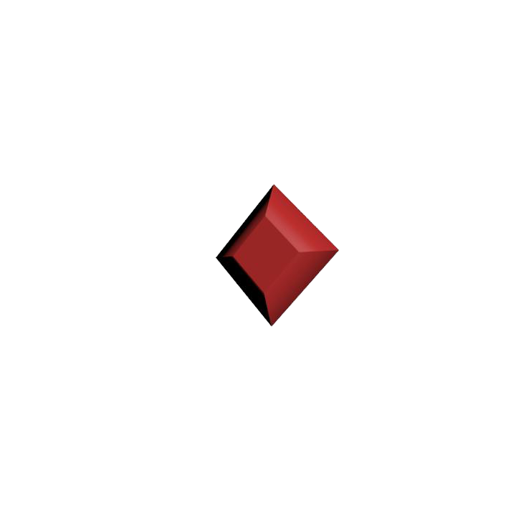
Power Gem: The most ubiquitos resource, the Power Gem has many uses. It increases Blobby's size, his density (for calculating the effect of breaking platforms), it recharges the boost, and it gives the player points for collecting them. These exist to guide the player through the level and provide them with the tools to succeed.

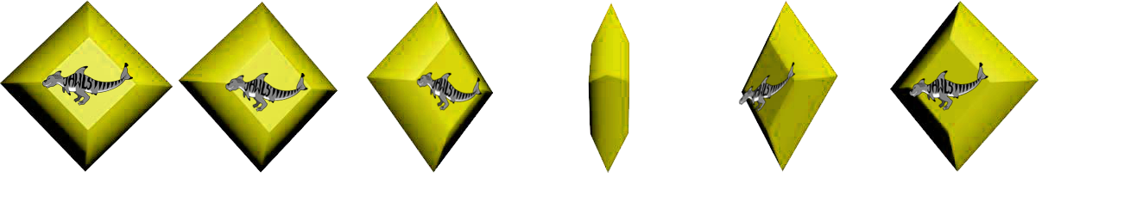
Multiplier Gem: The multiplier is a rarer resource. It increases the points the player can receive from Power Gems and also increasing the rate at which the boost regenerates and how much the Power Gems replenish the boost for a short time. These exist to give the player something to search for and find while playing the game.

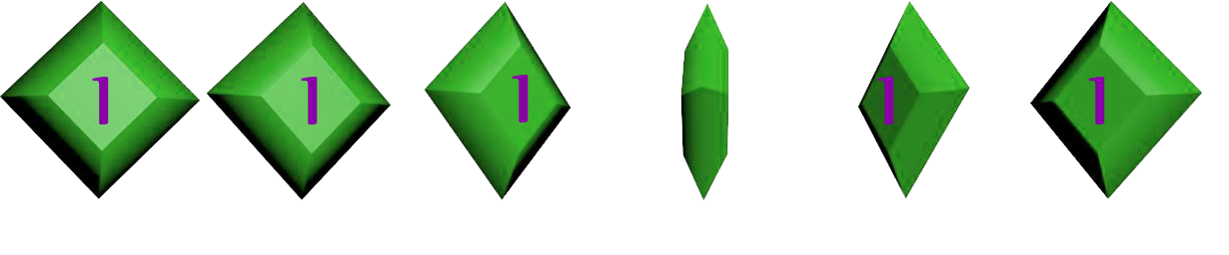
Life Gem: This gem gives Blobby an extra life. It exists to help out players who have difficulty with the game by giving them additional chances to succeed.

Portal: The portal gives Blobby an immediate boost to his speed. It is there to help players get through the level.

Slow Portal: This portal slows Blobby instead of speeding him up. It exists so that players cannot just steamroll through the level.



Platform: The platform stops Blobby if he is moving too slow to break it and slows him down even if he can break it. It exists to provide challenges so that the player's progression can feel meaningful. It would be no fun to fall through an empty level.

Game Environment
The environment that the game takes place in is a large “chute” that holds the level and stops the player from leaving the play area. The background is made up of stars and clouds, so the game appears to be taking place in the sky. The environment and “terrain” have no impact on the actual gameplay.
Blobby will likely end up having around 5 levels, though with the in game level editor, it is very easy to make more. For now, 1 or 2 levels will suffice. Levels will be vertically stretched. While there may be branching pathways, the levels will all be far taller than they are wide simply due to the nature of the game.

Game Controls
Blobby moves left and right with A and D (eventually there will be the option to move with the left and right arrow keys or an Xbox controller instead). Players can use S (or down arrow/A button) to boost. These are the only actual gameplay controls.

Visual Design
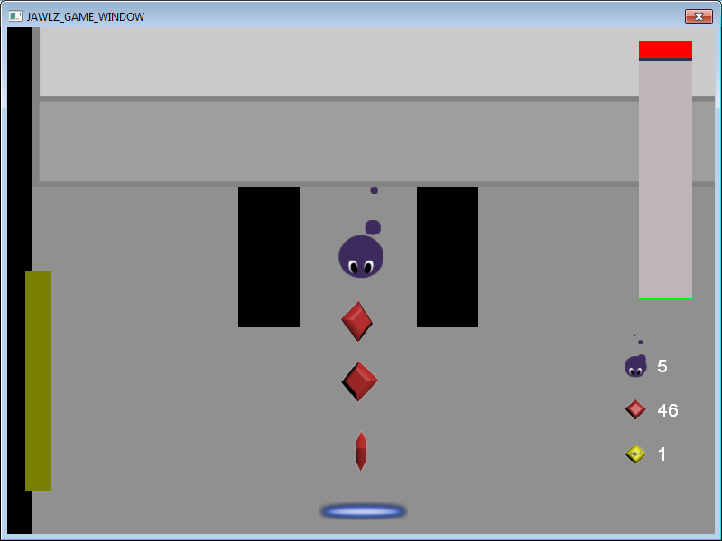
Blobby is a 2D game. There is no perspective. The camera follows Blobby as he falls, revealing upcoming obstacles and Gems only as Blobby continues to fall. There are no special effects (Particles are a work in progress). The look of the game is very stylized and cartoony, like Kirby or the Katamari games. No specialized lighting is needed. The overall feel that we are going for is light-hearted like Kirby, but also intense.

Audio Design
The music of Blobby prominently features percussion instruments that create a driving, moving feel to the game. There are different music tracks for different levels as well as the main menu screen. We were inspired by Igneous's brilliant use of drums to create that intense feeling. (Music can speed up and slow down depending on how fast Blobby is moving.) There are no recorded voices in the game. Sound effects should be silly sounding and cartoon-like.

Behavior Design
Currently computer controlled characters have no behavior or AI. (Basic movement patterns would help bring the world to life and make it feel more dynamic than static.) The only character beside Blobby is the guillotine, which should feel menacing. It's behavior is that it accelerates as it falls, moving faster and gaining on Blobby if the player takes no special action such as boosting.

Physics Design
The physics needed by Blobby are gravity, as that force governs how quickly things fall, as well as simple collision and response. (Ideally, rotating objects would be good, as it would allow for the creation of more organic-feeling levels)

Multiplayer Design
Blobby does not support multiplayer.

Appendix A: Art List
Sprites
All sprites are in 32 bit .png format to allow for alpha transparency. Sprite animations need to be created with frames evenly spaced in a horizontal line. The following is an example of how the sprites will be listed here:
Filename: Sprite Description. Size (pixels). Animation and Frame numbers.

Arrow.png: A simple arrow that is used to warn the player when the guillotine draws near. 512 x 512. No animation.
audioslider.png: A stretched gray triangle for a slider. 256 x 64. No animation.
Blob.png: Blobby, the main character, is a purple circle with eyes and trailing purple dots forming a tail. 2048 x 1024. Has a falling animation with 5 frames.
BlobbyUp.png: A spinning green gem with a picture of Blobby on it, serves as Life Gem sprite. 2048 x 256. Has a horizontal spinning animation of 6 frames.
bUTTON.png: Blue box that acts as a button. 1024 x 124. Has a 2 frame animation for mouse over and mouse off.
buttonOutline.png: A blue glowing outline that appears when the button is selected. 512 x 256. No animation.
Cellect.png: A red spinning gem that serves as the Power Gem sprite. 2048 x 256. Horizontal spinning animation of 6 frames.
checkpoint.png: A checkered rectangle that represents a checkpoint. 512 x 512. Swaps between 2 frames of animation to make it look like it is flickering back and forth.
CreditsScreen.png: A sprite that contains text for the credits screen. 800 x 2000. No animation.
digipenLogo.png: A sprite used on the DigiPen splash screen. 4096 x 1024. No animation.
FireParticle1.png: A sprite used for a fire particle. 8 x 6. No animation.
FireParticle2.png: A sprite used for a fire particle. 8 x 6. No animation.
FireParticle3.png: A sprite used for a fire particle. 8 x 6. No animation.
guillotine.png: A gray sprite resembling a guillotine blade for the guillotine sprite. 1024 x 1024. No animation.
HowtoPlay1.png: Sprite for the How to play screen with text on it. 800 x 600. No animation.
HowtoPlay2.png: Sprite for the How to play screen with text on it. 800 x 600. No animation.
HowtoPlay3.png: Sprite for the How to play screen with text on it. 800 x 600. No animation.
HowtoPlay4.png: Sprite for the How to play screen with text on it. 800 x 600. No animation.
JawlsGrey.png: Team logo that appears on loading screen. 392 x 187. No Animation.
JAWLZX2.png: Sprite for the Multiplier Gem, a yellow, spinning gem with the team logo on it. 2048 x 256. A horizontal spinning animation of 6 frames.
LoseScreen.png: A screen with a lose message and score text. 800 x 600. No Animation.
MenuBackground.png: Sprite for the menu background consisting of blue sky and wispy clouds. 800 x 600. No animation.
Particle.png: A simple blue particle. 8 x 6. No Animation.
pauseBackground.png: A transparent gray box for the pause background. 512 x 512. No animation.
platform.png: A blue box that has a breaking animation and serves as the platform. 2048 x 16384. Shattering animation, 7 frames.
Portal.png: A flashing blue and white portal for the portal sprite. 8192 x 128. Pulsing animation 11 frames.
Sky.png: A background with large clouds. 576 x 576. No animation.
Sky2.png: A background with wispy clouds for the level. 576 x 576. No animation.
Space.png: A space background with stars for the level. 576 x 576. No animation.
square.png: A white box for the HUD that is later overlaid with color. 16 x 16. No animation.
SlowPortal.png: A flashing orange and white portal for the slow portal sprite. 8192 x 128. Pulsing animation 11 frames.
Transfer from space to sky 1.png: A transition from the space background to the second transition. 576 x 576. No animation.
Transfer from space to sky 2.png: A transition from the first transition to a sky background. 576 x 576. No animation.
WhiteBackground.png: A simple white-gray background for the level. 64 x 64. No animation.
WinScreen.png: A screen with a win message and score text. 800 x 600. No Animation.
Fonts
Blobby does not use custom fonts. Only the Arial built in font is used.

Source
Blobby's art comes predominantly from Alex Ginter, a Sophomore BFA who is not part of Team Jawlz. Other art comes from our programmers. Concept art by Diane Tey, Sophomore BFA. Jawlz Logo by Jessica Parker, Freshman BFA.

Appendix B: Audio List
Sounds
All sounds are stereo and do not loop. //Sampling frequency? Bit rate? Compression????
Hit_ImpactWood02.wav: Plays when Blobby breaks a platform.
Magical_EnergyLoop01.wav: Plays when Blobby clears a level.
ButtonPressISuppose.wav: Sound for clicking on a button.
Pickup_GemBells14.wav: Sound for collecting a Power Gem.
Pickup_GemBells16.wav: Sound for collecting a Multiplier Gem.
Pickup_MagicBells10.wav: Sound for collecting a Life Gem.
RocketLauncher_Shot03.wav: Sound for boosting.
Title Crystal Hit 01.mp3: Sound for boosting from a portal.
Scifi_DomeShield_Deactivate3.wav: Sound for passing through a slow portal.
DeathShortened.mp3: Sound for when the guillotine catches Blobby.
Music
All music is stereo and loops by default.
Blobby – Menu.mp3: The music that plays in the background for the main menu.
Blobby – Theme 1: Soundtrack for a level.
Blobby – Theme 2: Soundtrack for a level.
Blobby – Theme 3: Soundtrack for a level.
Source
Sounds provided by the DigiPen Sounds Library. Music provided by Professor Steven Saulls.

